**Slope of a line secant to a curve**

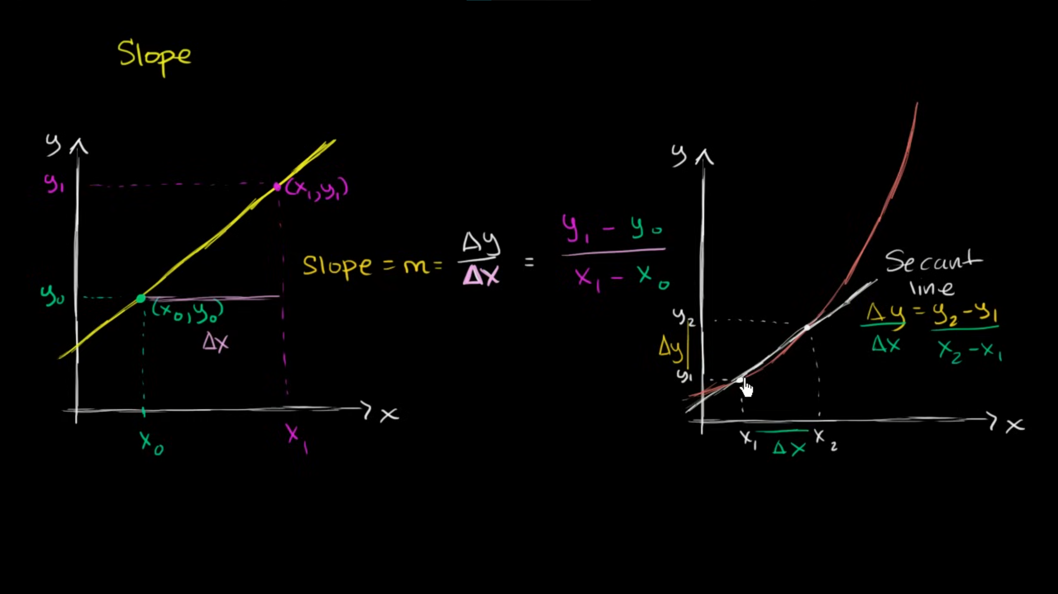

**Secant line with arbitrary difference**

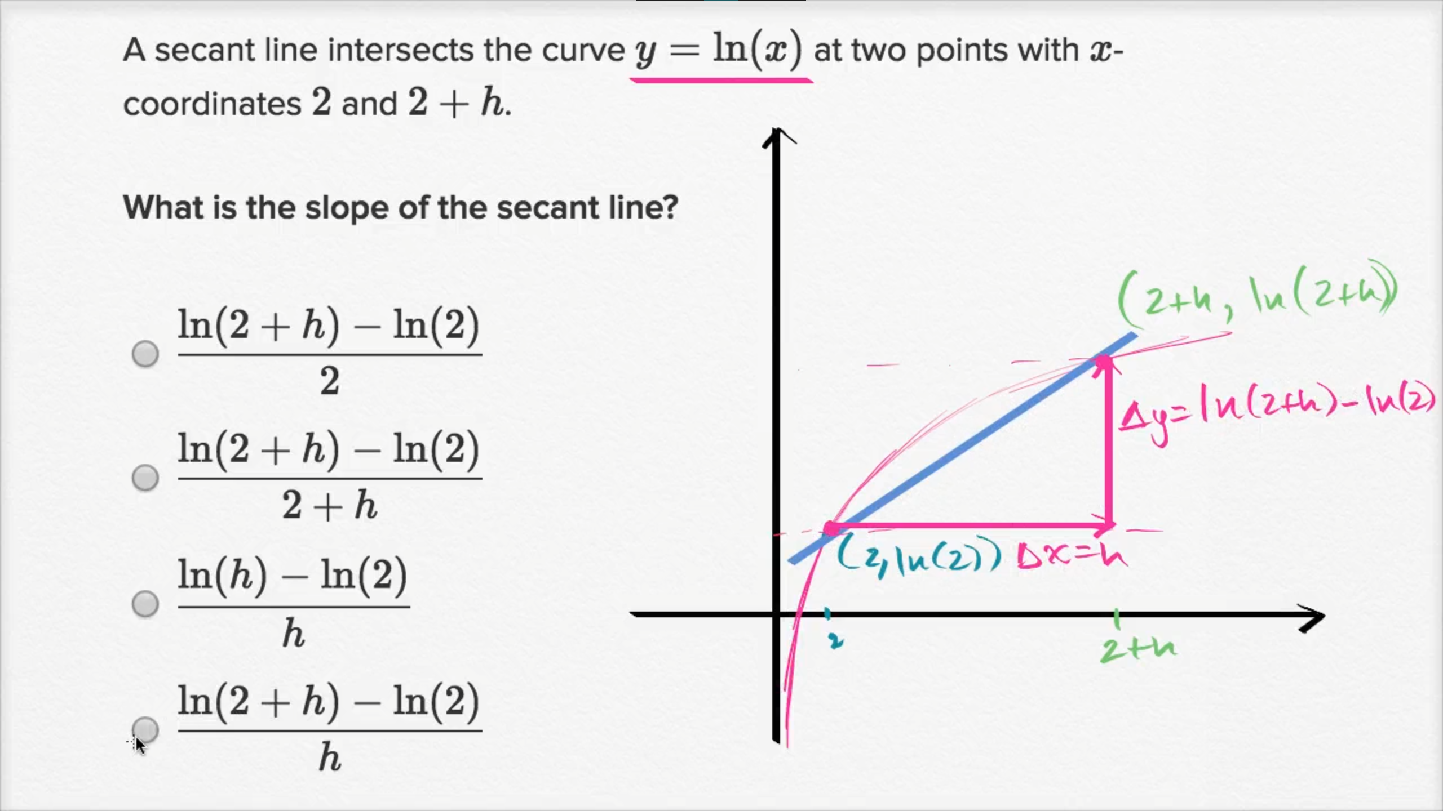

**Secant line with arbitrary point**

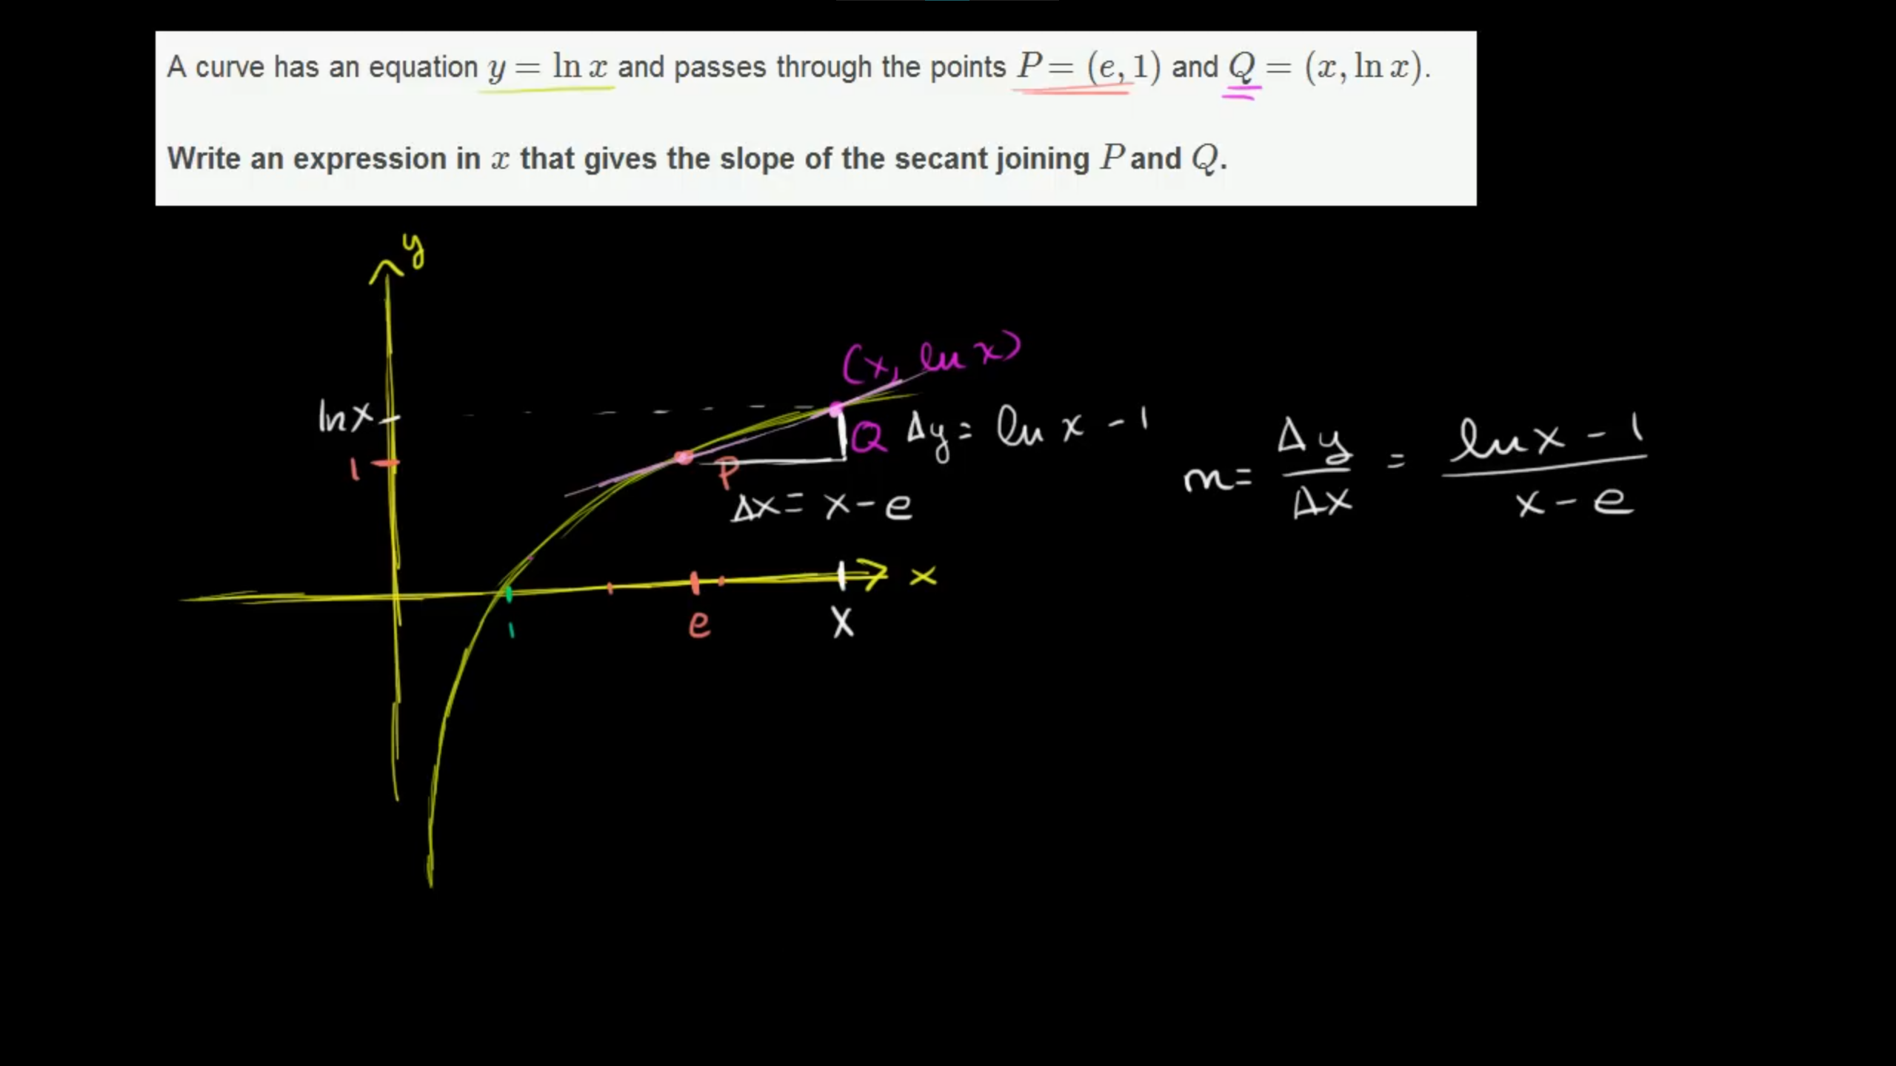

**Secant line with arbitrary difference (with simplification)**

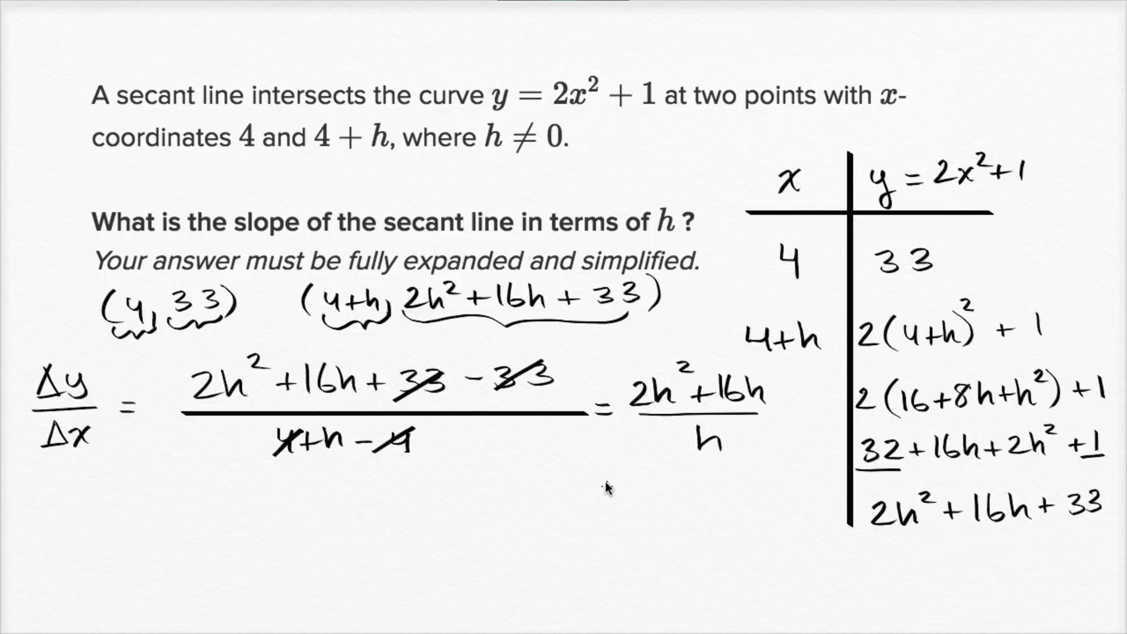

**Secant line with arbitrary point (with simplification)** 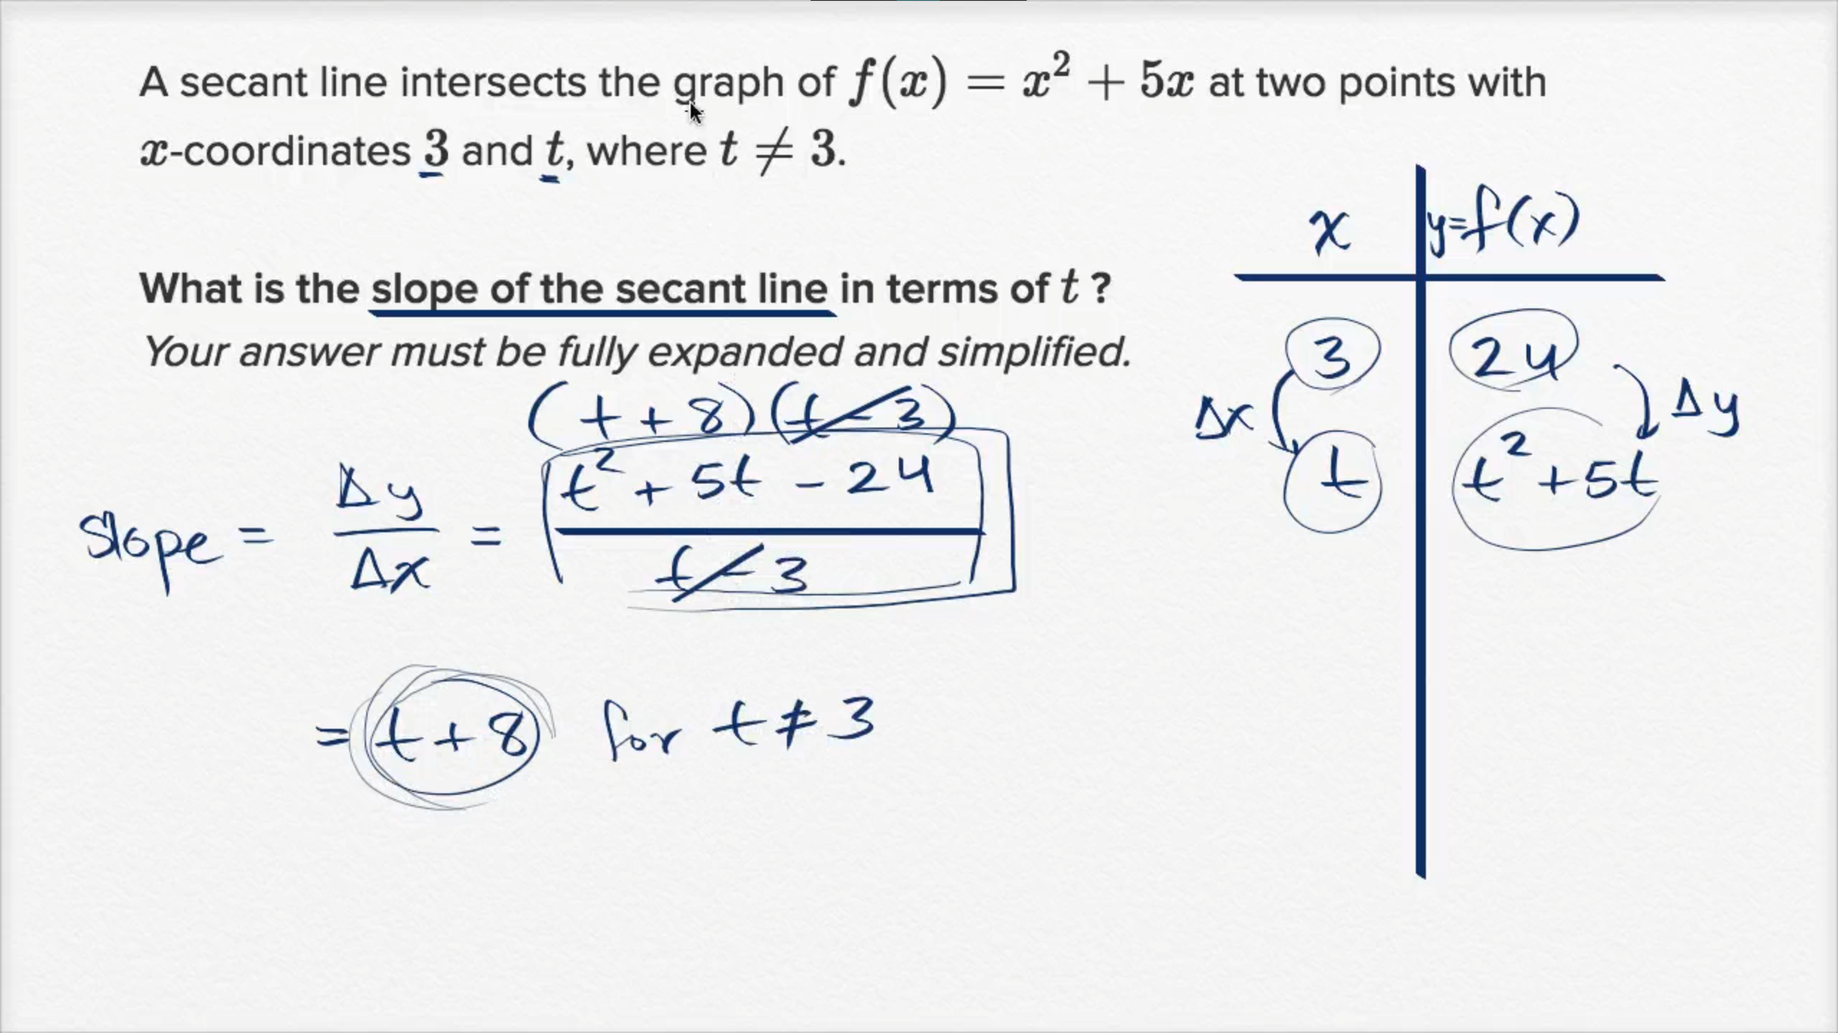

**Secant lines: challenging problem 1**

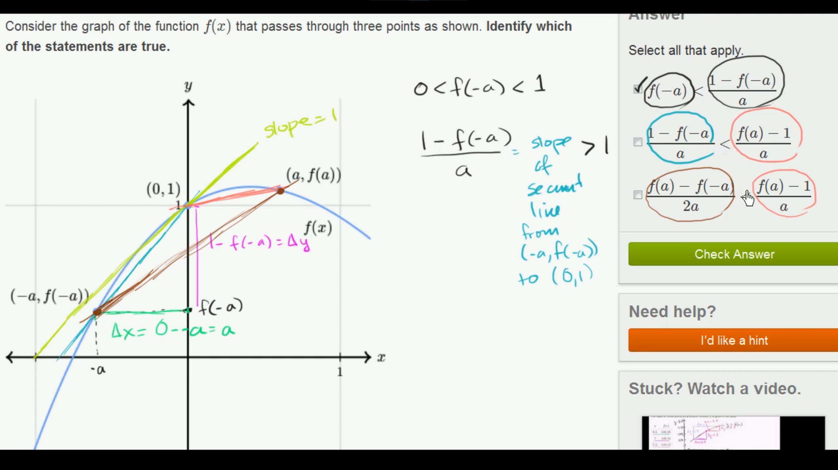

**Secant lines: challenging problem 2**

